Project name:

# ***The Tragedy of flight:A comprehensive crash analysis***

Team members:

***1 . P Neevitha***

***2 . S Gunavathi***

***3 . S Srimathi***

***4 . A Anitha***

INTRODUCTION

* 1. ***Overview***

*The process of conduting an airplane crash analysis typically involves the collection and analysis of a wide range of data, including information about the aircraft and its systems,the operators, and any other relevant factors.This data is typically collected from kaggle.Once the data has been collected , it is analysed through tablaeu ,to identify any potential causes of the accident. The results of an airplane crash analysis are typically published in a report,which may include recommadations for improving safety and preventing similar accidents in the future.These recommadations may be implemented by the relevant authorities or industry organizations.*

* 1. ***Purpose***

*The goal of an airplane crash analysis is to identify any factors that contributed to the accident,with the ultimate goal of improving safety and preventing future accidents.*

1. *Problem definition & Design Thinking*
   1. *Empathy map*

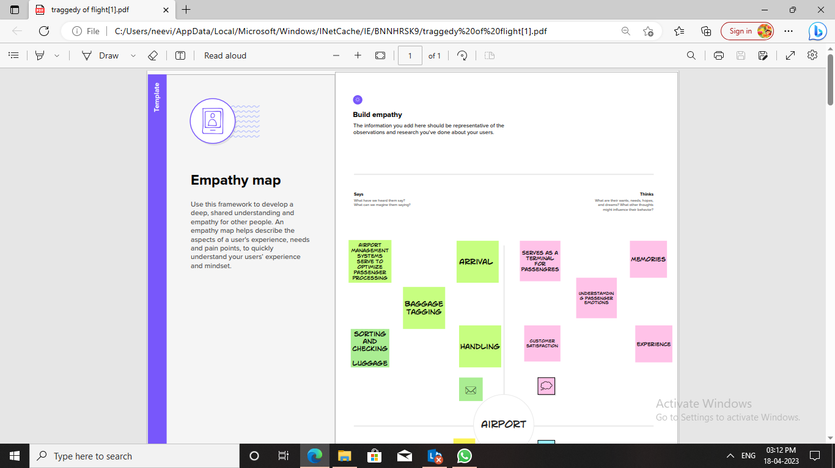

# C:\Users\neevi\Pictures\Screenshots\Screenshot (3).png

# Ideation & brainstorming map screenshot



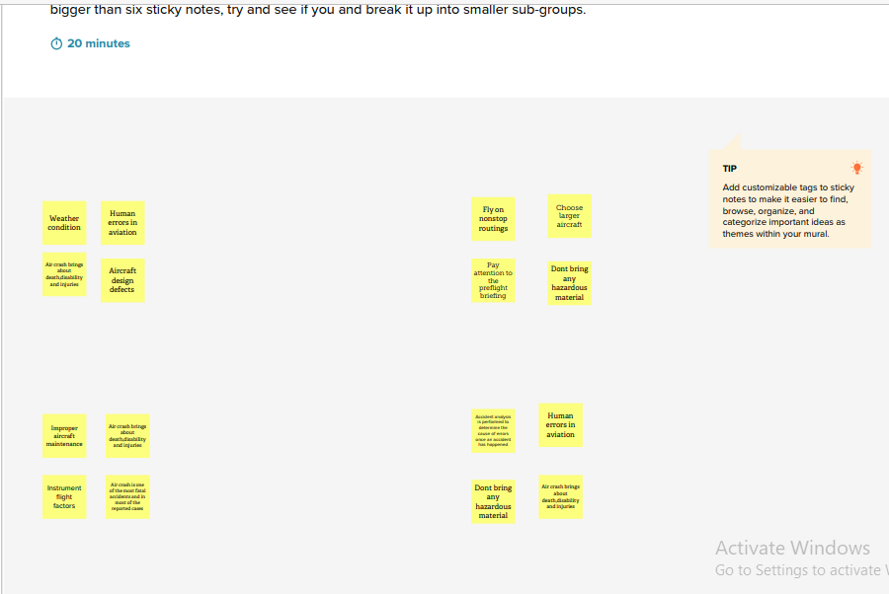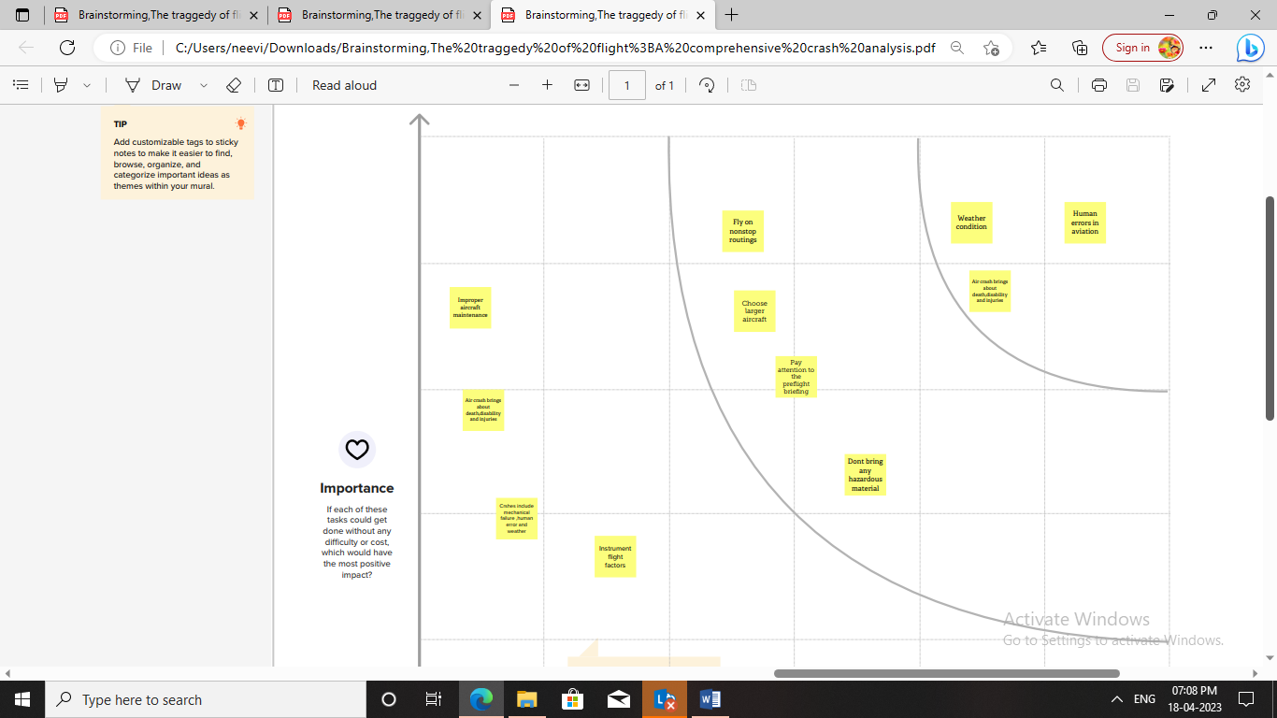

1. Result

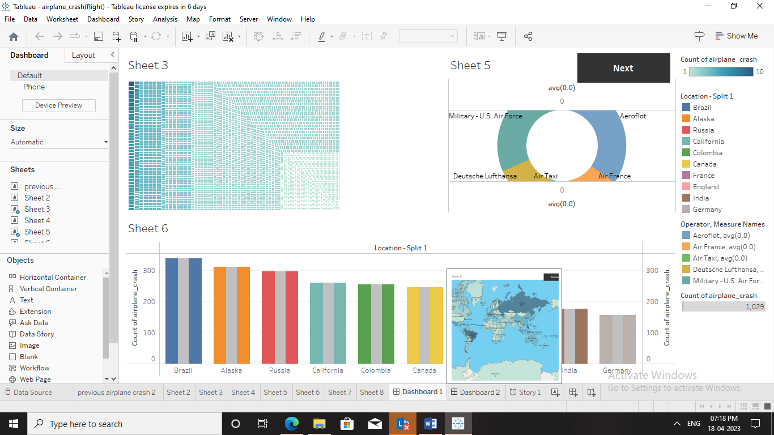

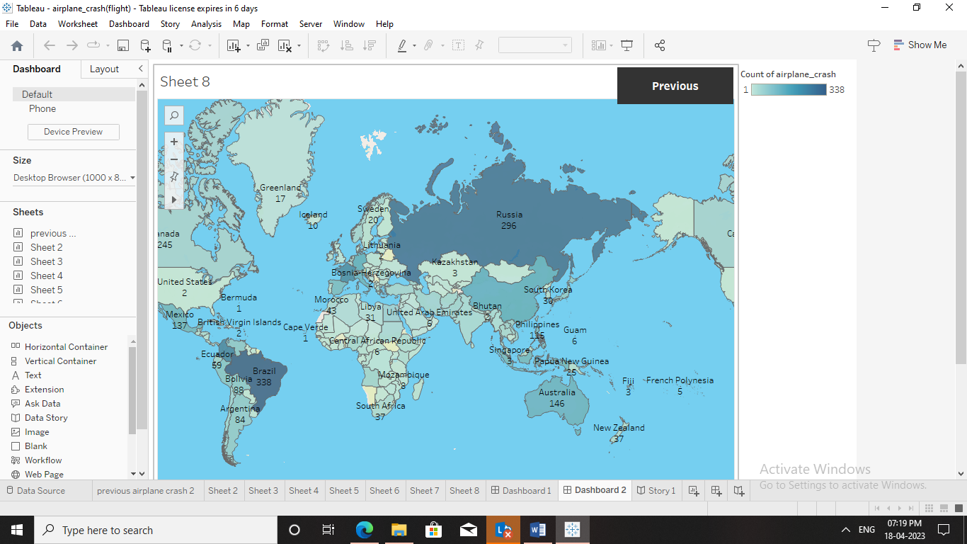

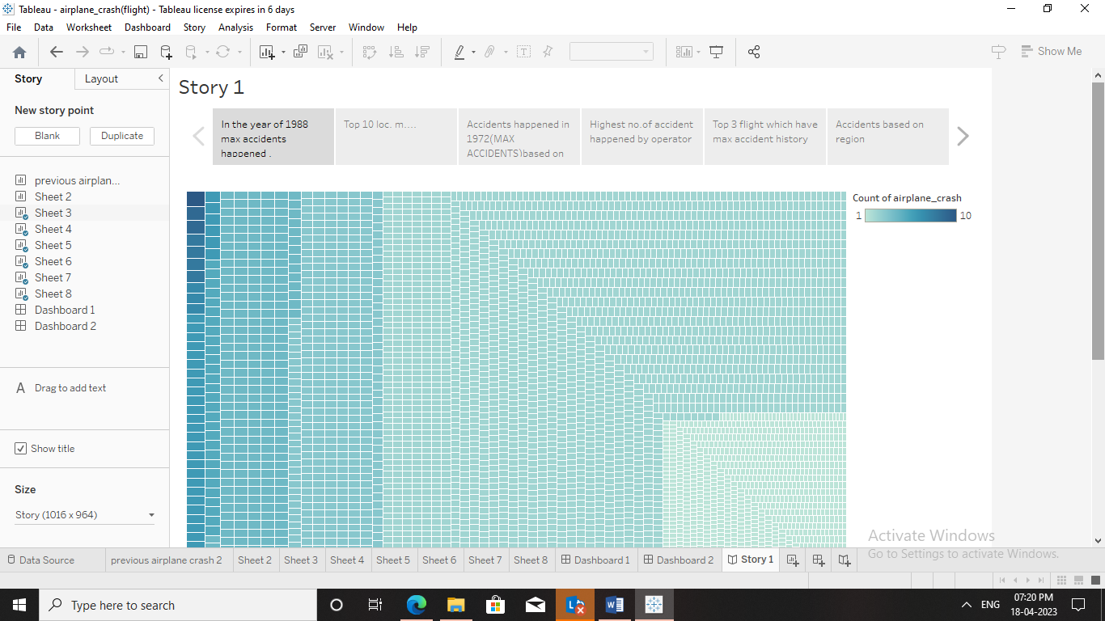

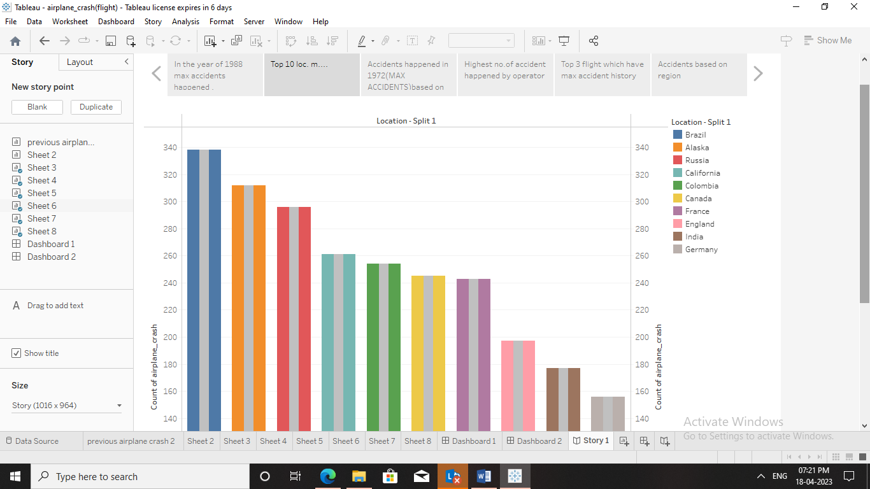

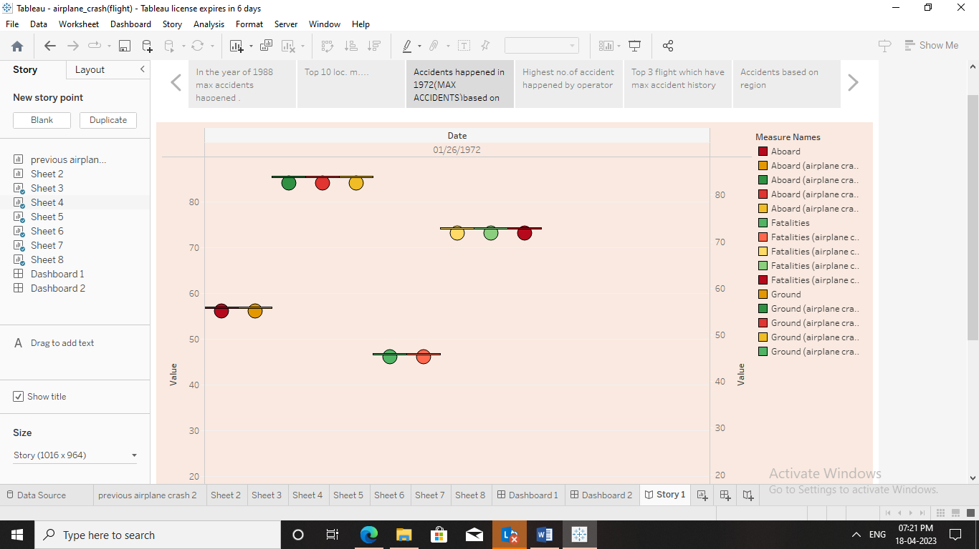

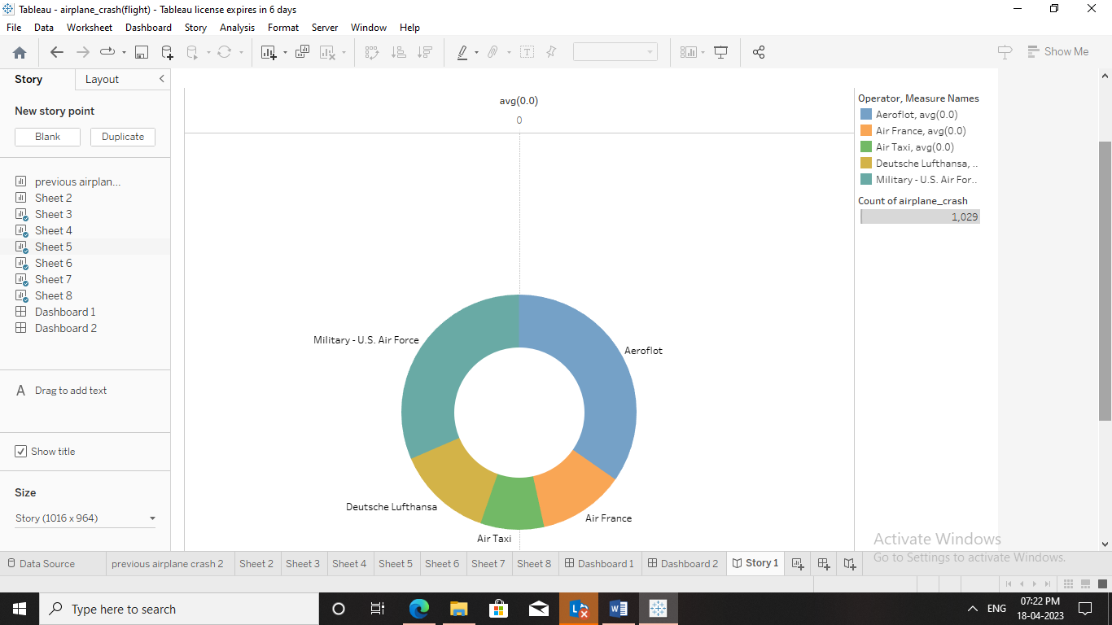

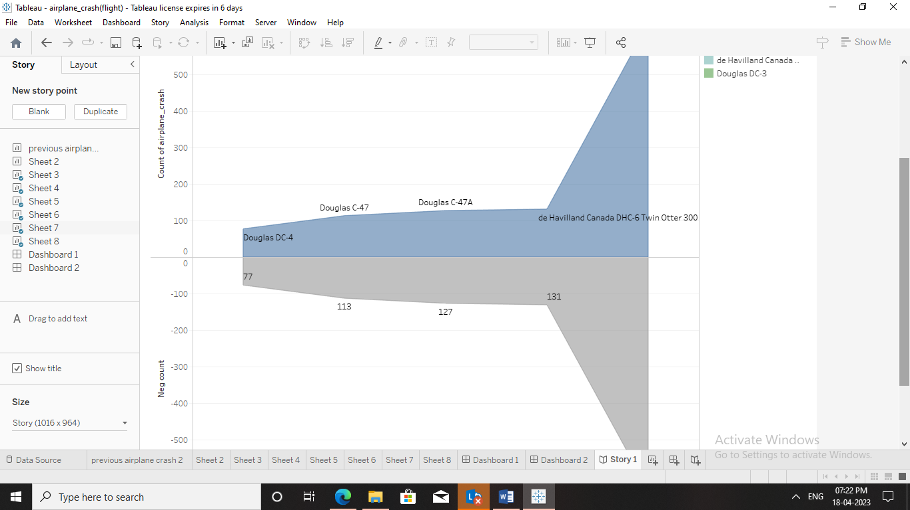

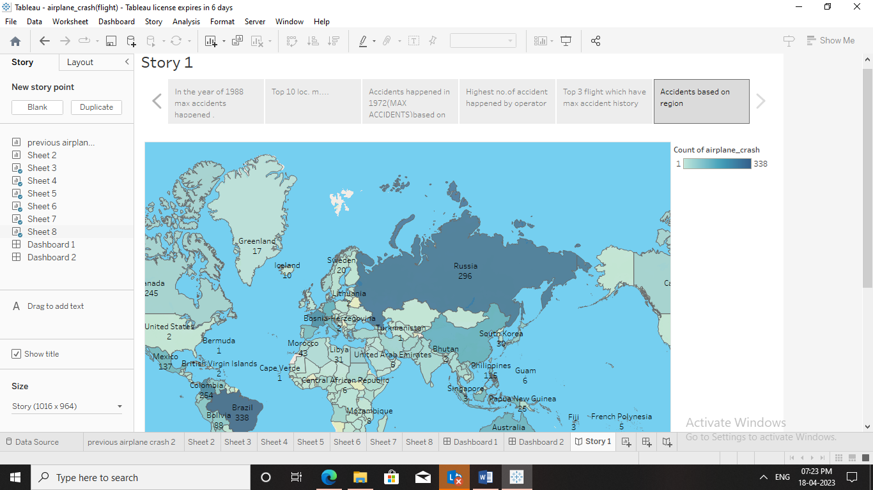

1. *ADVANTAGES & DISADVANTAGES*

***Advantages***

*Travelling by plane is a chance to explore new places,meet new peoples and experience.*

*One of the most advantages features offered by air transport is its speedly delivery times.*

***Disadvantages***

*That flying can be cramped and uncomfortable,especially if you’re one crowded flight*.

1. ***APPLICATIONS***

*Examine several major that control towers and flight crews worldwide.*

*An accident in which an aircraft hits land or water and is damaged or destroyed.*

***6 CONCLUSION***

*We have explained new investigators explored various scenarios that could explain the downing of flight*.

***7 FUTURE SCOPE***

*A recent report suggested that hydrogen-powered planes could enter the market as soon as 2035,and those planes could carry hundreds more passengers per flight than traditional planes,with a cleaner energy source.*

***8 APPENDIX***

***Source code***

*file:///C:/Users/neevi/AppData/Local/Temp/Temp1_Airplane%20crash%20analysis-20230417T040857Z-001.zip/Airplane%20crash%20analysis/index.html*